Summer is soon ending and there are a lot of management decisions coming up. Our Sales Agronomists are here to help you with those decisions and provide you with the best recommendations for your operation. Crop Service Center looks forward to meeting your everyday needs and providing you the service you need to be successful.

Featured Items
• • •
- Website update
- Meet Team Members
- Soybean Pests and Nutrition
- What’s Happening at Crop Service
- Wheat Fertility

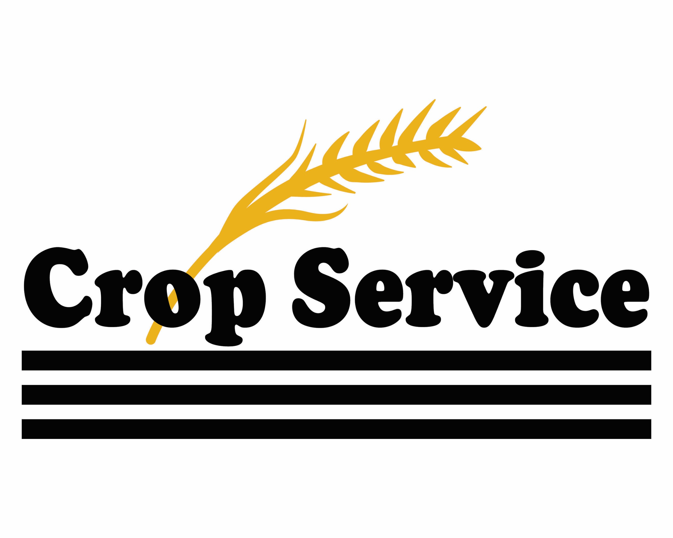

“I can't imagine anything more important than air, water, soil, energy and biodiversity. These are the things that keep us alive."
- David Suzuki

Crop Service Center, Inc.
Knowledge. Care. Commitment. | August 2019

Website Update
Our website is currently being updated with new information. Check back often to see the new changes and keep up to date with Crop Service!
www.cropservicecenter.com
Soon we will begin with text and email updates to keep you up to date with seasonal crop events, such as crop insect problems and timely input opportunities. On the bottom of the website, there is a sign up for both text and email, please enter your number and/or email as well as your name.
**Note: If you have signed up in the past, you will need to re-signup as we have recently updated the list. **
If there is any information you would like to see in a future newsletter or on the website, please let your Sales Agronomist or Sarah Zerger know.
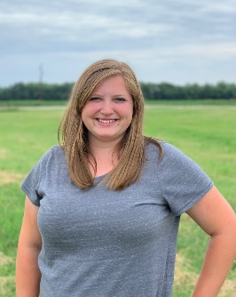
Meet Members of our Team!
Sarah Zerger started at Crop Service Center in July of 2019. She graduated from K-State University in 2018 with a bachelors in Agronomy and a minor in Animal Science. She is originally from Cheney, KS where her family has a certified seed wheat business, diversified cropping system, and a cow-calf operation. Sarah is a Certified Crop Advisor and has her 1A Certified Pesticide Applicator license. Sarah will be working on enhancing the precision ag program for Crop Service and working on the newsletters and website.
Marilyn Marston started at Crop Service in February 2019. She grew up around the Abilene area. She is married to Dennis Marston and they have one daughter, Nicole, who is married to Sam Shrack. They have two grandchildren, Axie and Stetson. In her free time, she likes to participate in competitive horse trail riding, where she rides 60 miles over the weekend. Marilyn is responsible for the company’s accounts receivable.

Soybean Pests and Nutrition
Soybeans are in full flower stages, which means there will soon be a lot more insects in the fields. Once pods begin to set, stink bugs, bean leaf beetles, podworms, green cloverworms and thistle caterpillars will be the main pests to look for.
Stink bugs, bean leaf beetles and podworms can cause the most damage to the soybean pods as they eat through the pods and seeds and can transmit diseases. Each of these can transmit different diseases that reduce grain quality or cause significant yield loss. Green cloverworms and thistle caterpillars can cause loss of leaf area, which can decrease plant productivity and have minor yield losses.
This year, we are promoting some fungicide, insecticide and foliar feeds for soybeans to help give the protection and boost they need for the end of the season. Check the Crop Service website for more information about these products or ask your Sales Agronomist about what these products can do for your crop.
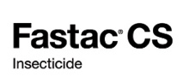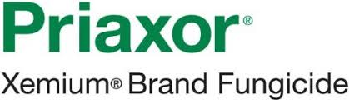

What’s Happening at Crop Service!
Attend the Kansas Corn Central District listening tour August 28th 6-8 pm at Sterl Hall, 619 N Rogers St Abilene, KS. Dinner and refreshments will be provided. Topics discussed will include trade, ethanol, new corn uses, education and more. Visit the Crop Service website to find more information and RSVP.
Wheat Fertility

Wheat planting will soon be around the corner and planning for your crop’s success will be the first step. Soil fertility is one of the most important factors in setting up your crop for success. The first step in your decision-making process should revolve around a soil test.

  - Soil sampling
This is a valuable tool to help decide how much fertilizer your crop will need. Depending on the level of management intensity, a composite or grid sample will determine the nutrients and amounts needed. Crop Service offers soil sampling and our knowledgeable agronomists will go over the results and create recommendations with you.

  - pH and lime
A minimum soil pH of 6 is needed to help maximize the production of wheat. When pH is too low, you begin to lose nutrient availability and the increased probability of Aluminum toxicity. At Crop Service, we have lime with a guaranteed ECC of 70% and can apply blanket (single rate) or variable rate applications.
In addition to raising the soil pH, here are five other benefits of liming your soils:
- supply Calcium and Magnesium
- increase Phosphorus availability
- promote root development
- increase microorganism activity
- and help fix Nitrogen in the soil
Source: Drs. Eghball and Sander, Univ. Nebraska
Fluid Journal, Winter 2001
  - Starter fertilizer
Applications of nitrogen (N), phosphorus (P), and potassium (K) help give your wheat the jumpstart it needs, to put out the optimal number of tillers, and get it through the winterization period. If grazing in either the spring or fall, a higher rate of a starter fertilizer might be considered for higher production of tillering. Adding in Zinc to your starter fertilizer is a good way to give some added benefits to your crop and increase your soil levels.

Contact Us:
Holland Location: 1123 Eden Rd, Abilene, KS, 785.479.2206
Abilene Location: 818 SE 4th, Abilene, KS, 785.263.3037
Dale Koop: 785.479.3753 dale@cropservicecenter.com --- Owner
Mark Crane: 785.479.3750 mark@cropservicecenter.com --- Holland Location Manager
Reed Koop: 785.479.3758 reed@cropservicecenter.com --- Sales Agronomist
Trent Frye: 785.479.3751 trent@cropservicecenter.com --- Sales Agronomist
Sarah Zerger: 316.217.1687 sarah@cropservicecenter.com

Crop Service Center
818 SE 4th St
Abilene, KS 67410

